# CS 255 System Design Document

Sean Reid

CS 255

8/14/2022

### UML Use Case Diagram

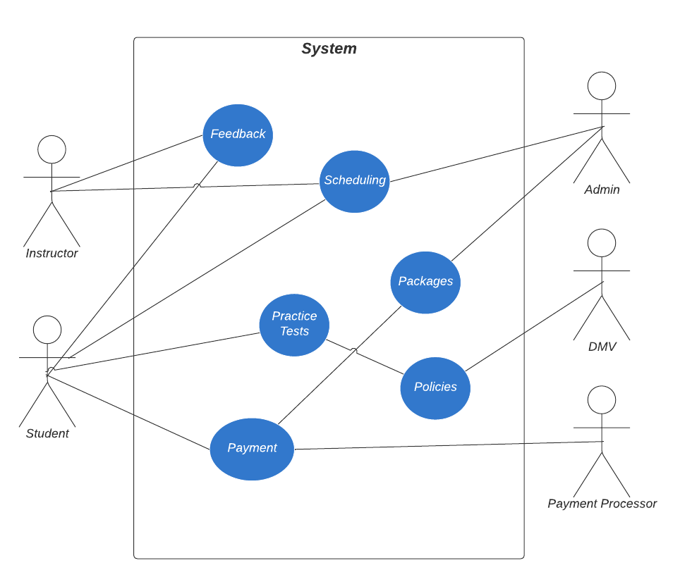

### UML Activity Diagrams

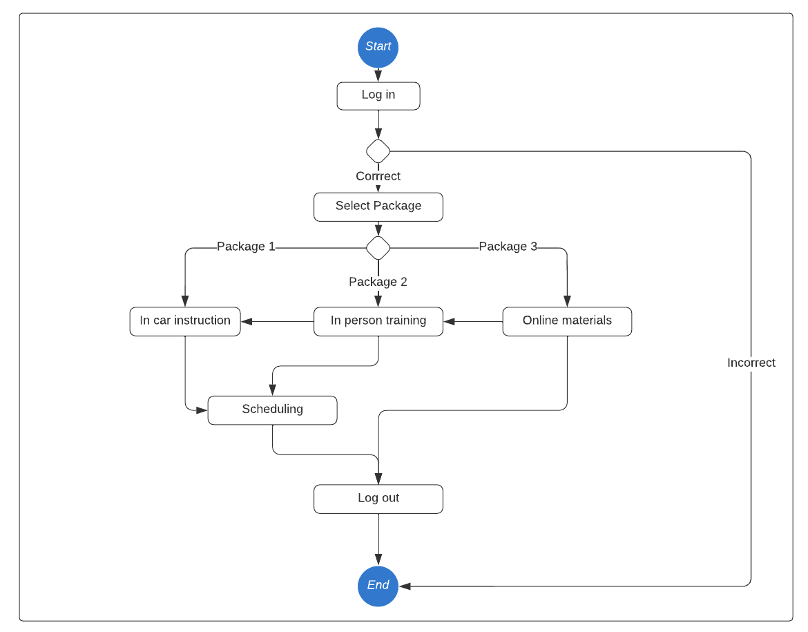

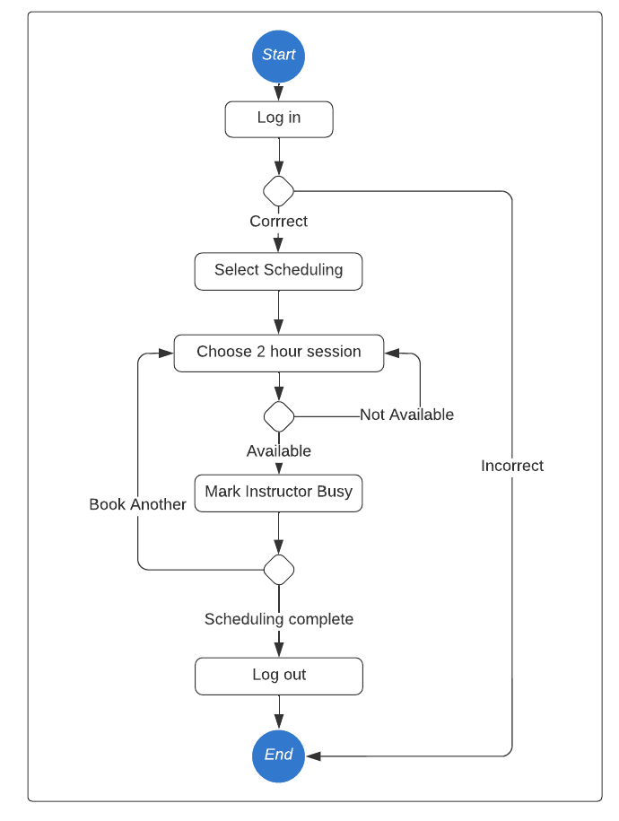

### UML Sequence Diagram

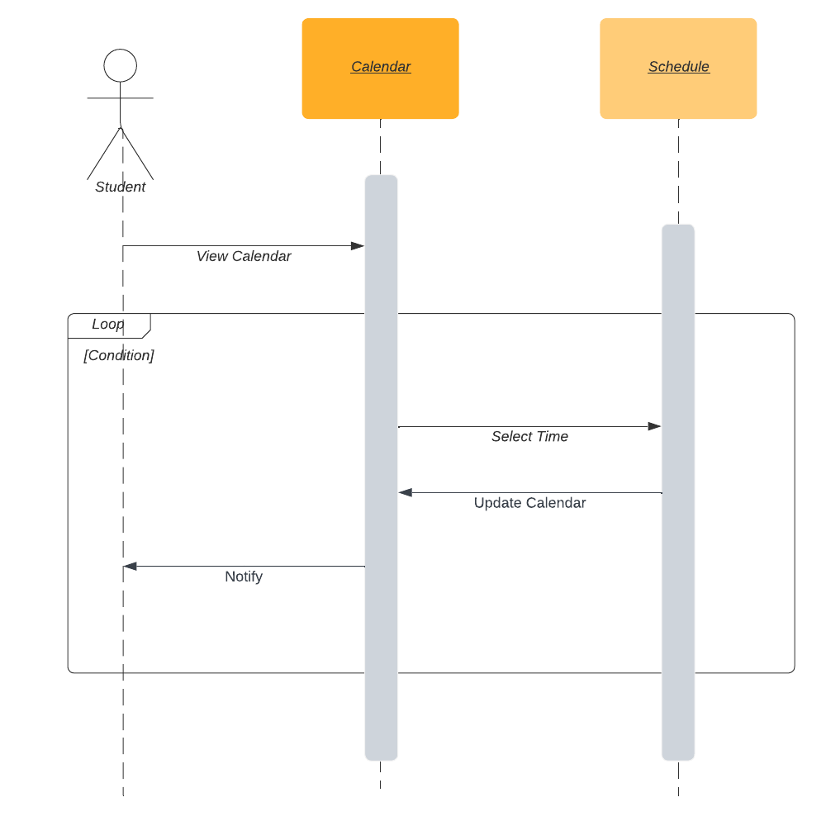

### UML Class Diagram

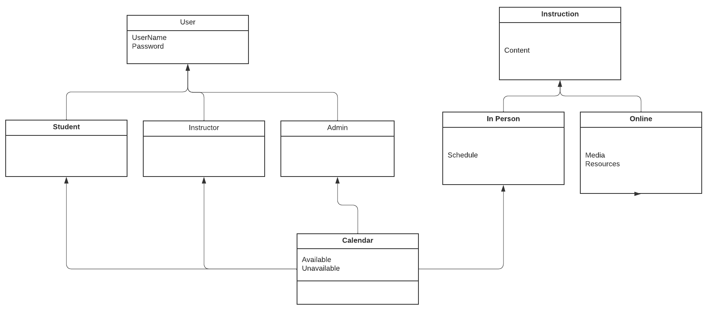

## Technical Requirements

*[Based on the diagrams you have created, describe the technical requirements of your system. These requirements should address the required hardware, software, tools, and infrastructure necessary for your system design.]*

The system will require the following:

**Hardware**

The system will require a database server. Likely the best fit will be a relational database such as Postgres. Postgres on Linux would be the most cost effective way to house the database. Creating an AWS RDS instance would get things up and running quickly and affordably.

The system will require a web server. For the web server, we will need some form of Linux machine running Java, likely a Java Maven / Spring Boot back end with ReactJS front end. We can either run the application on AWS ECS behind an application load balancer or just run it on Fargate. A containerized application makes local testing easy to run locally and test. Alternatively we can set up AWS API Gateway to serve the content. We can discuss further with the client and weight pro’s and cons.

**Software**

As discussed under hardware, we will use Postgres to run the database, ReactJS with Typescript on the front end, Java Maven / Spring Boot on the back end API.

**Tools**

IntelliJ Idea is recommended for Java

Webstorm or VS Code is recommended for ReactJS

**Infrastructure**

The required infrastructure will be acquired by utilizing a cloud provider. AWS is our cloud provider of choice. Azure or Google Cloud can be made available, although timelines and cost may be increased based upon fees and the adoption of new services and knowledge.